KPI’S

1.Total Revenue
select round(sum(total_price),2) as total_revenue from pizza_sales;
Output:

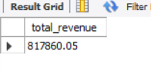
2. Average Order Value
select round(sum(total_price) / count(distinct order_id),2) as AOV from pizza_sales;
Output:
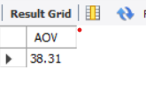
3. Total Pizzas Sold
select sum(quantity) as total_sold from pizza_sales;
Output:
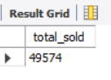
4. Total Orders
select count(distinct order_id) as total_orders from pizza_sales;
Output:
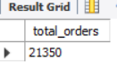
5. Average Pizzas Per Order
select round(sum(quantity) / count(distinct order_id),2) as average_pizzas_per_orders from pizza_sales;
Output:
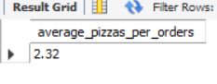

Chart Requirement.
6. Daily Trend For Total Orders
select dayname(order_date) as days ,count(distinct order_id) as Total_sale from pizza_sales
group by days
order by total_sale desc;
Output:
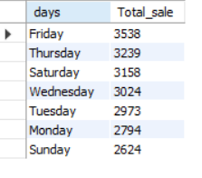

7. Hourly Trend For Total Orders
select hour(order_time ) as Order_Hour,count(distinct order_id) as total_orders
from pizza_sales
group by Order_hour
order by Order_hour;

Output:

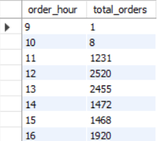

8. Percentage Of Sales By Pizza_Category
select pizza_category,
round(SUM(total_price),2) AS category_sales,
round(SUM(total_price) * 100 / SUM(SUM(total_price)) OVER (),2) AS sales_percentage
From pizza_sales
GROUP BY pizza_category
ORDER BY sales_percentage DESC;

Output:
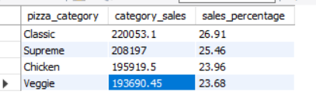

9. Percentage Of Sales By Pizza_Size
Select pizza_size,
Round(sum(total_price),2) as size_sales,
Round(sum(total_price) * 100 / sum(sum(total_price)) over(),2) as pct
From pizza_sales
Group by pizza_size;

Output:
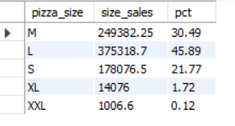

10. Top 5 Best Seller Pizza By Total Sold
select pizza_name, sum(quantity) as total_sold from pizza_sales
group by pizza_name
order by total_sold desc limit 5;

Output:
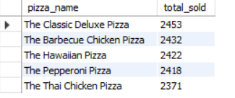

11. Top 5 Bottom Seller Pizza By Total Sold
select pizza_name, sum(quantity) as total_sold from pizza_sales
group by pizza_name
order by total_sold limit 5;

Output:
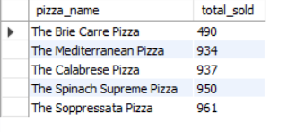

END

